FOR THE FAMILY

YOUR REFERRAL TO NOAH’S ARK CHILDREN’S HOSPICE

Your child has been referred to Noah’s Ark Children’s Hospice. If you are unaware of this or no longer consent, please discuss with the referrer.

We welcome the referral of babies, children and young people who met our referral criteria and live within our core catchment area of Barnet, Camden, Enfield, Haringey, Hertsmere and Islington. We consider referrals outside our catchment area in exceptional circumstances and on a case-by-case basis, in discussion with the lead hospice for the area.

WHAT HAPPENS NEXT?
All referrals are given careful consideration on receipt. If the referral is for Emergency, End of Life or Care After Death we will respond urgently and contact you directly. All other referrals will be considered at our next multidisciplinary panel meeting which will be within two weeks.

If we have all the information needed to make a decision of acceptance promptly, we will allocate a Family Link Worker who will contact you to arrange a home visit to start the Assessment process.

We may need to seek further information from medical professionals involved with your child’s care such as consultants or your GP. In order to process your referral in a timely manner, please ensure an NHS number is provided on the referral form and attach an up-to-date clinic letter.

WHAT IF MY CHILD IS NOT ACCEPTED?
Sadly, we cannot offer support to every baby, child or young person referred to us. Our primary focus is on those babies, children or young people who meet our criteria. If your child is not accepted, we may be able to suggest other services you can consider contacting.

You are free to speak to us at Noah’s Ark Children’s Hospice to ask us to reconsider a decision if you think there are factors, we may have overlooked. Re- referrals are welcome at any time, should your child’s condition change.
If you have any questions, please contact us on: 0208 449 8877 or email noahs.referrals@nhs.net

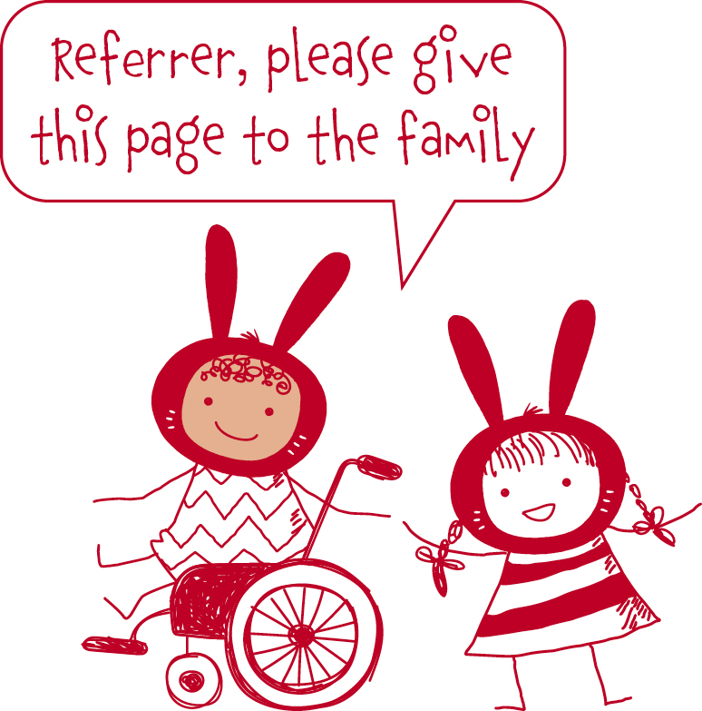

REFERRAL FORM FOR ALL CARE SERVICES

REFERRAL TYPE
Routine Urgent admission End of life

Noah’s Ark Children’s Hospice accepts referrals for children under 18 years based on the following criteria, in line with guidelines used by Children’s Hospices.

GROUP 1 | Life threatening conditions for which curative treatment may fail, e.g. cancer, irreversible organ failure. | Yes/No
GROUP 2 | Conditions where premature death is anticipated but intensive treatment may prolong life e.g. complicated cystic fibrosis, HIV. | Yes/No
GROUP 3 | Progressive conditions without curative treatment options where treatment is exclusively palliative e.g. Battens disease, mucopolysaccharidoses. | Yes/No
GROUP 4 | Conditions causing severe neurological disability leading to susceptibility of health complications and likelihood of premature death e.g. severe cerebral palsy, multiple disabilities following brain or spinal cord insult. Group 4 children may need to undergo further assessment if eligibility is not clear using this criteria. | Yes/No

CHILD’S DETAILS
Child’s last name |  |  |  | Child’s first name
Child’s NHS no. |  |  |  | Child’s age
Date of birth |  |  | Male/Female/Non-binary
Ethnicity |  |  |  |  | Religion
Family address
Borough |  |  |  |  | Postcode
Tel no. |  |  |  |  | Email
Primary language |  |  |  |  | Interpreter required? Yes/No

PARENTS / CARER DETAILS
Last name |  |  | First name |  |  | Title
DOB |  | Relationship to child |  |  | Do they have parental responsibility? | Yes/No
Are they the main carer? |  | Yes/No
Last name |  |  | First name |  |  | Title
DOB |  | Relationship to child |  |  | Do they have parental responsibility? | Yes/No
Are they the main carer? |  | Yes/No
Details of shared care arrangements (if applicable):

SIBLINGS DETAILS
Last name | First name | DOB | Gender? M/F

General Practitioner
GP name |  | Telephone
Address and postcode
ICB |  |  | Email

SCHOOL DETAILS
Contact name and position | Name and address of school | Telephone number and email

PROFESSIONAL’S DETAILS
Name of professional | Role | Address | Telephone number and email

MEDICAL DETAILS
Diagnosis:

Please specify all medical conditions and care needs:

Date diagnosed (approx)
Likely prognosis:

Current phase of illness – please check one box:

Stable Unstable Deteriorating Dying Unknown

Please attach any relevant documentation such as a recent clinic letter to support the application.

ADVANCE PLANNING
Is there an Advance Care Plan / ReSPECT document in place? Yes No

If yes, please attach or supply further details below. If no, what discussion have taken place?

Is there a Symptom Management Plan? Yes No
Please give a brief description of how you feel Noah’s Ark can help the child and family referred. Please include any additional information you feel would be helpful with this referral.

Who or what prompted you to make this referral?

IF THERE ARE SAFEGUARDING CONCERNS, PLEASE GIVE BRIEF OUTLINE:

Please tell us if the child subject to any of the following:

Child Protection Plan Child in Need Plan Care Order Child Arrangements Order
Special Guardianship Order Child in Care; by voluntary agreement (s.20)

PLEASE DETAIL CURRENT CARE PACKAGE:
Social Care (short breaks / care hours/ overnights / personal budget): | Continuing Care (care hours / overnights / personal health budget):
Allocated Social Worker and telephone number: | Continuing Care Matron and telephone number:

REFERRER’S DETAILS
Full name |  |  |  |  | Role/relationship to child
Address |  |  |  |  |  |  | Postcode
Tel no. |  |  |  | Email
Date of referral

How did you hear about Noah’s Ark?
Already working in partnership Local professional networking Noah’s Ark Presentation
Noah’s Ark Fundraising Event Family or Friend GOSH crèche/music therapy service
Other, please state:

CONSENT TO REFERRAL AND TO SEEK AND SHARE INFORMATION

For those unable to consent and children under 16:

I, the parent/guardian, give consent to the referral. Yes No

For young people aged 16 years or above:

Does the young person have capacity to consent to the referral? Yes No

If so, has consent been given to the referral? Yes No

In order to provide safe and effective care, Noah’s Ark Children’s Hospice will need to obtain or share your child’s up to date personal details, and general medical & social care information, including clinic letters, copies of prescriptions (FP10), emergency care plans and advance care plans from other professionals including (but not limited to) schools, community teams, GPs, hospitals, local authorities and/or clinical commissioning groups.

I give permission for Noah’s Ark Children’s Hospice to seek and share health and social care information as outlined above: Yes No

Please note that by making this referral it may be necessary for us to request further medical information as
necessary.

Referrer’s signature |  | Date

Parent/Carer’s signature |  | Date

Please send the completed form to us by post or email. If you are emailing outside of the nhs.net network, please
note that this is not secure so please password protect the sent documents and send the password in a separate
email.

Post: The Ark, Byng Road, Barnet EN5 4NP | Email: noahs.referrals@nhs.net

Referrals for Urgent / End of Life Care or Care After Death through Noah’s Ark Children’s Hospice can be directed to the 24/7 Nurse-on-Call number: 020 3994 4134. Please leave a message and your call will be returned within 1 hour. The on-call Registered Nurse can advise on the referral immediately or plan a call back following discussion with the Referral Panel Members. Urgent referral forms be emailed to noahs.nurses@nhs.net

